9. Plot of Contoured Diagrams of Orientation Data

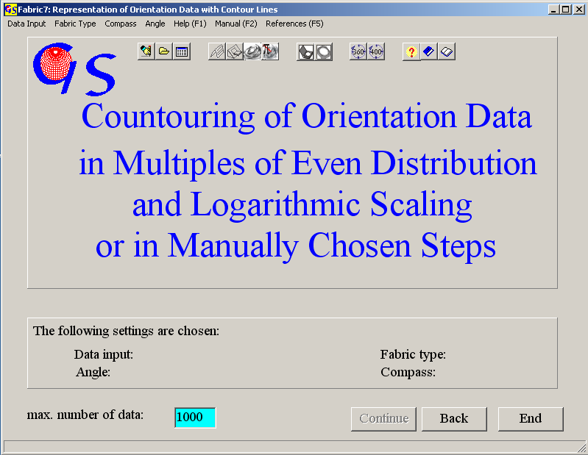
Fig. 1

This program (Fig. 1) plots contoured projections of orientation data. Starting form and data input are the same as in Programs 3, 4, and 8. The distance between the contours can either automatically be calculated in multiples of even distribution in logarithmic steps, or user defined. In the first case five contour levels are calculated. The steps are logarithmically arranged from 1 % to the maximum of density. The counting calotte is fitted to the number of data. In the second case, The steps of five contour levels are put in manually. In this case the size of the counting calotte must be chosen.

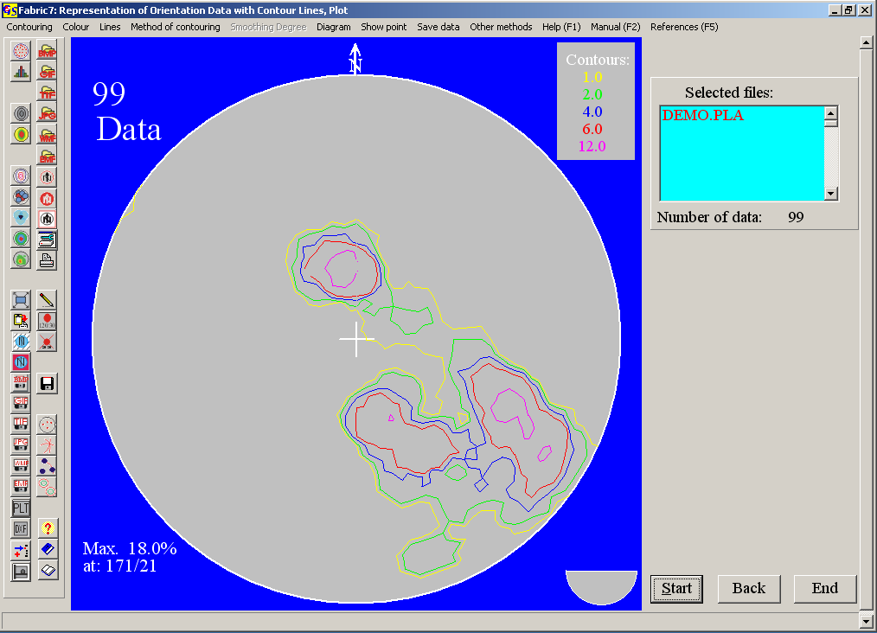
Fig. 2

Fig 2 shows the evaluation of the data used for program 4 in logarithmic steps as multiples of even distribution.. The calculated contour lines are listed in the upper left corner. The calculated maximum appears in the lower right corner. The type of contour intervals is saved in “fabric7.ini” and can be changed in the menu “Contouring” or with the speed buttons (Fig. 3).

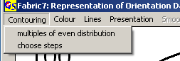
Fig. 3

Fig. 4 shows contour lines for the same data set with manual selection of contour levels and a counting calotte of 1%.
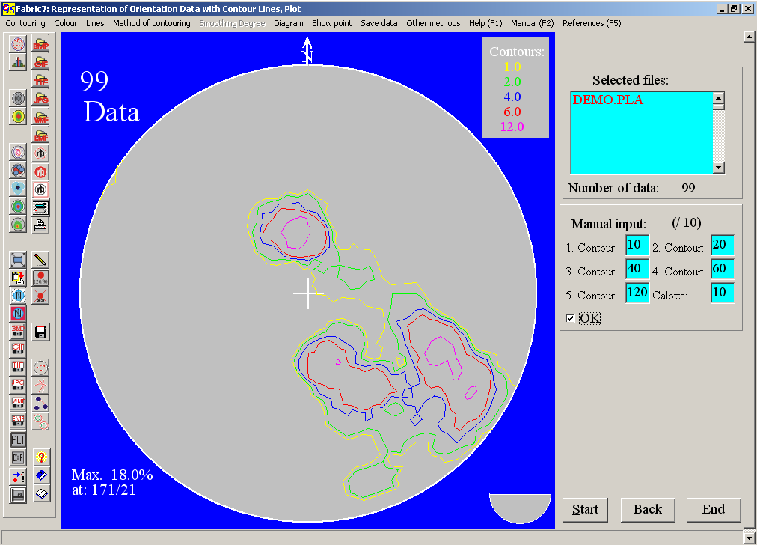
Fig. 4

With 'Diagram/save/PLT' or 'Diagram/save/DXF' the diagram can be saved as vector graphic. With 'Diagram/Plot with the printer' a vector graphic is printed. A panel appears on the right side (Fig. 5), in which the saved values for coordinates and radius are shown. You can change these values.
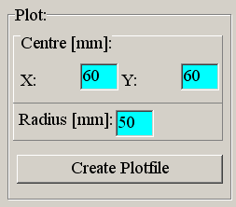
Fig. 5

After clicking 'Create plot file' you must choose the name of the Dxf- or Plt-file.

In the menu "Methods of contouring" (Fig. 6) the option "Calotte/Vectorgraphics" creates a contour line plot in vector graphics (Fig. 2, 4). The option "Calotte / Pixel graphics (in steps)" produces a diagram using the method of Mellis (1942).
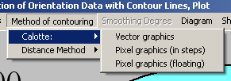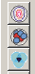
Fig. 6

Fig. 7 shows shows a diagram in pixel graphics with fixed steps between the density fields.
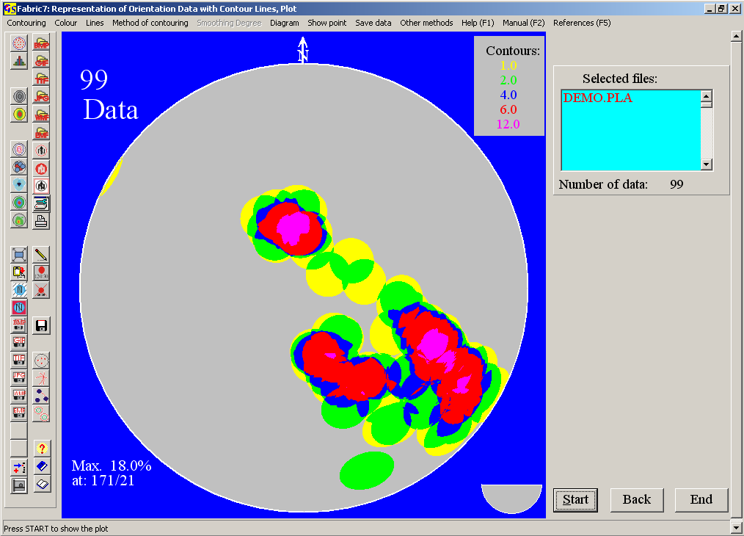
Fig. 7

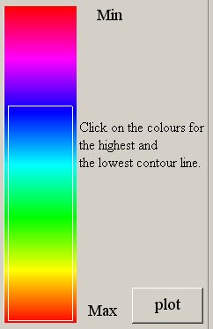Fig. 8

Fig.9 is drawn with the same method, but the densities are shown with floating boundaries. the colour are chosen from a pectrum of HLS colours. The whole spectrum of these colours is shown in Fig. 8. By clicking on the colours for the highest and lowest contour line you choose the colours to be used in the diagram. The diagram in Fig. 9 is drawn with the colours in the white frame (blue to red).

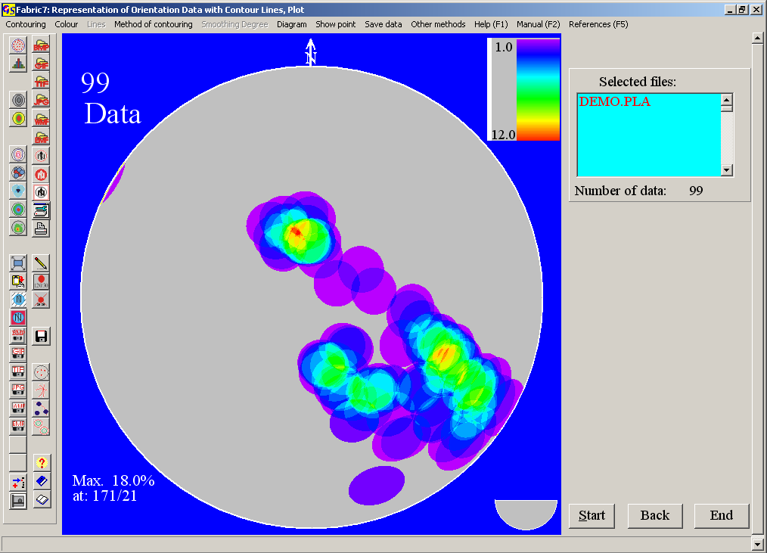
Fig. 9

Distance Methods:
These methods use each pixel of the projection area as counting point. The angle between the pixel-point and each data point is calculated. The sum of the cosines of these angles is calculated and compared with the value for even distribution (Adam, 1989). These values are arranged in contour intervals with different colours (Fig. 10). This method produces very smooth contours.

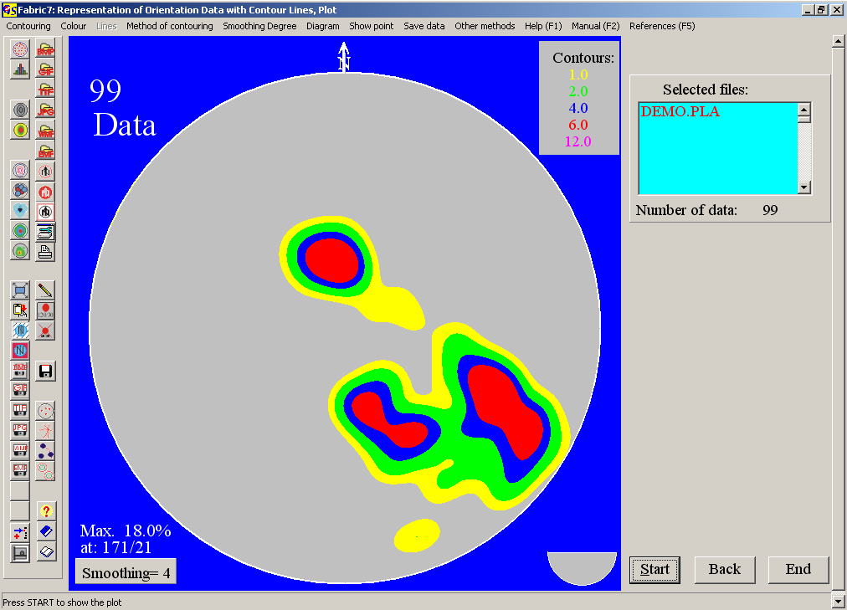Fig. 10

The smoothing factor is chosen from a scale from 1 (many details) to 10 (no details).

You can also choose floating contours with floating colours from the HLS-spectrum (Fig. 8). By clicking on the colours for the highest and lowest contour line you choose the colours to be used in the Diagram. The diagram in Fig. 11 is drawn with the colours in the white frame.
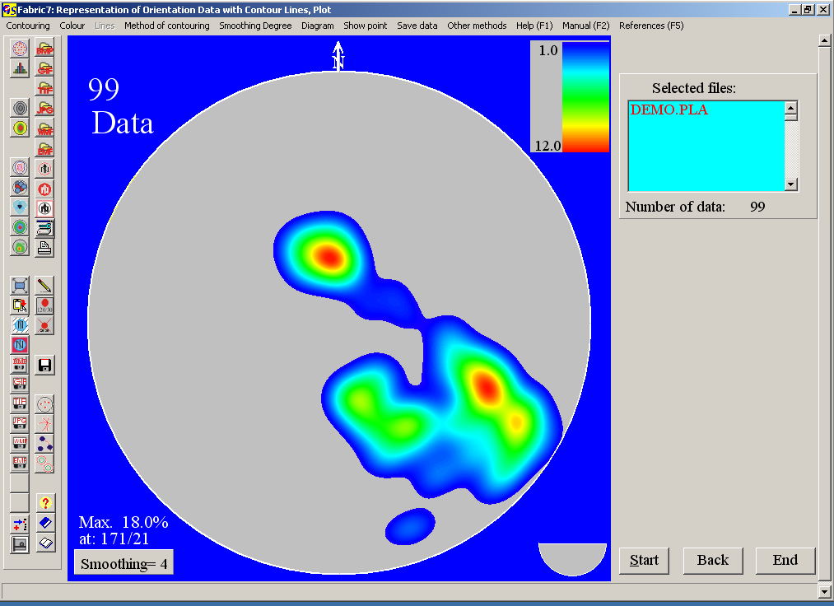
Fig. 11

Pixel-graphics cannot be used in the plot program, but they can be saved on the clipboard. With the option “Print” you can produce a hardcopy from the graphic.

It is also possible to draw closed polylines which follow the edges between the colours (Fig. 10). These polylines can be saved in a *.dxf file. This file can be trated with Autocad, CorelDraw, or any other graphic programm which reads Dxf-files.
The procedure is: Click 'Method of contouring/Distance method/In steps' and wait until the diagram is finished. Then click 'Graphic/Save/DXF'. On the right side a panel appears, in which the saved coordinates and the radius are shown. Change the numbers, if necessary (Fig. 5). Click on 'Create plot file' and type the name of the plot file. Wait until the polylines appear (Fig. 12). Now you can import the Dxf file to a graphic program.
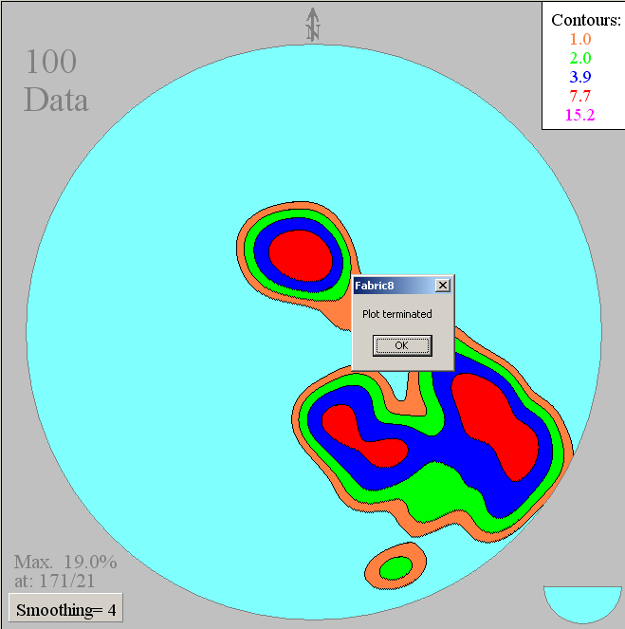
Fig. 12

Fig. 13 shows a CorelDraw graphic plotted with the Dxf-File,

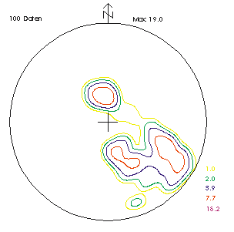
Fig. 13

With 'Diagram/Plot with the printer' the polylines can be printed, filled or not filled.

With the menu „Show point“ and clicking on a point in the diagram the azimuth and angle of dip of this point are shown (Fig. 14).

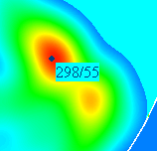
Fig. 14

With the menu "Evaluation" you can jump to the other programs which use orientation data.

Menus, not mentioned here, are described in program 3.

